**SQL Homework – 02** Fani Shundovska

1. Write a query to select all from the Order Details table where the unit price is between 14 and 50.

**SELECT** *

**FROM** `order details`

**WHERE** UnitPrice **BETWEEN** 14 **AND** 50;

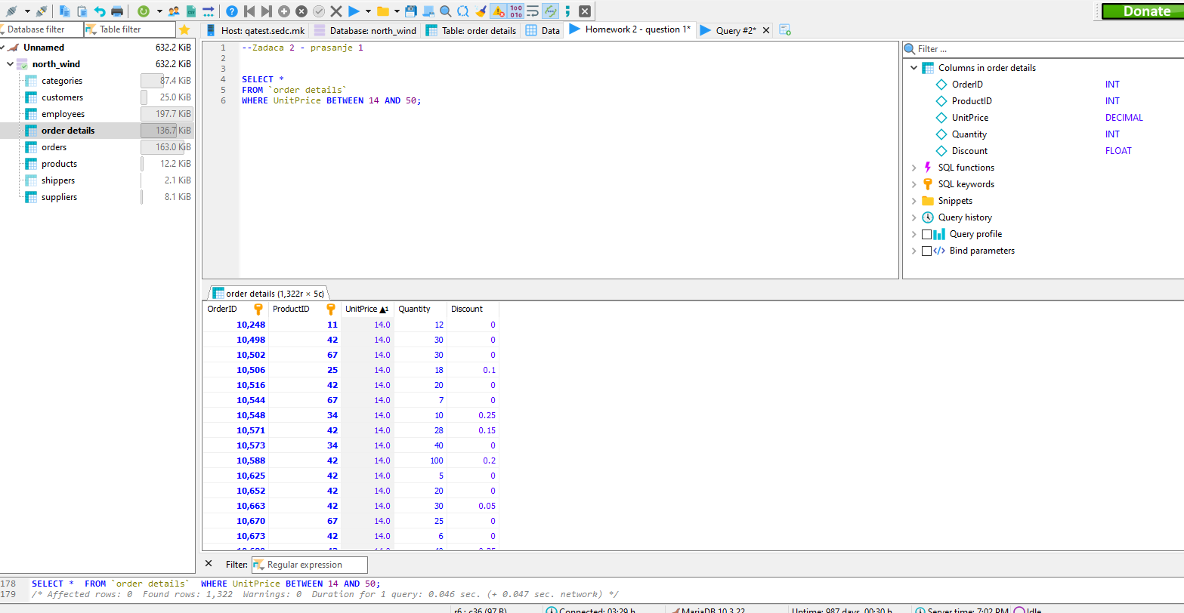

1. Write a query to select all from the Order Details table where the quantity is between 20 and 45.

**SELECT** *

**FROM** `order details`

**WHERE** Quantity **BETWEEN** 20 **AND** 45;

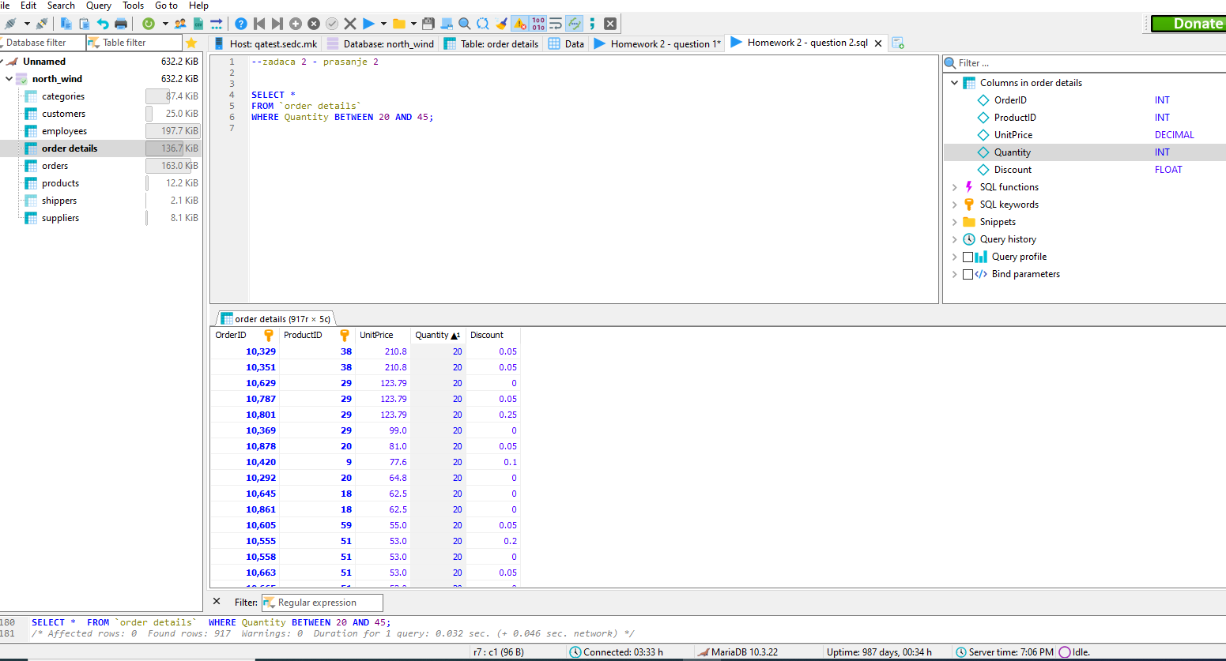

1. Now we will combine exercises 1 and 2. Write a query to select all from Order Details table where the unit price is between 15 and 50 or quantity is between 20 and 45.

**SELECT** *

**FROM** `order details`

**WHERE** UnitPrice **BETWEEN** 14 **AND** 50 **OR** Quantity **BETWEEN** 20 **AND** 45;

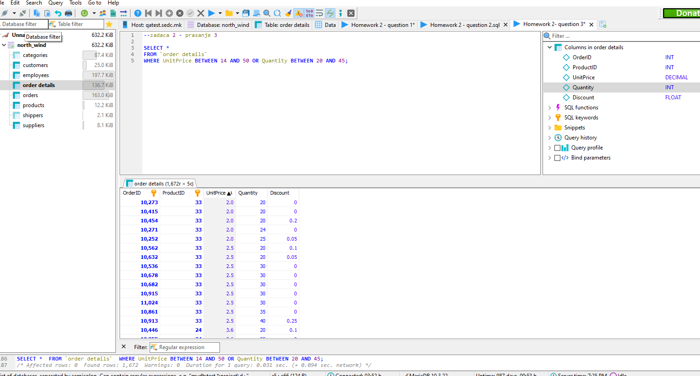

1. Write a query to select all from Order Details table where the product ID number is starting with the number 3.

**SELECT** *

**FROM** `order details`

**WHERE** ProductID **LIKE** '3%';

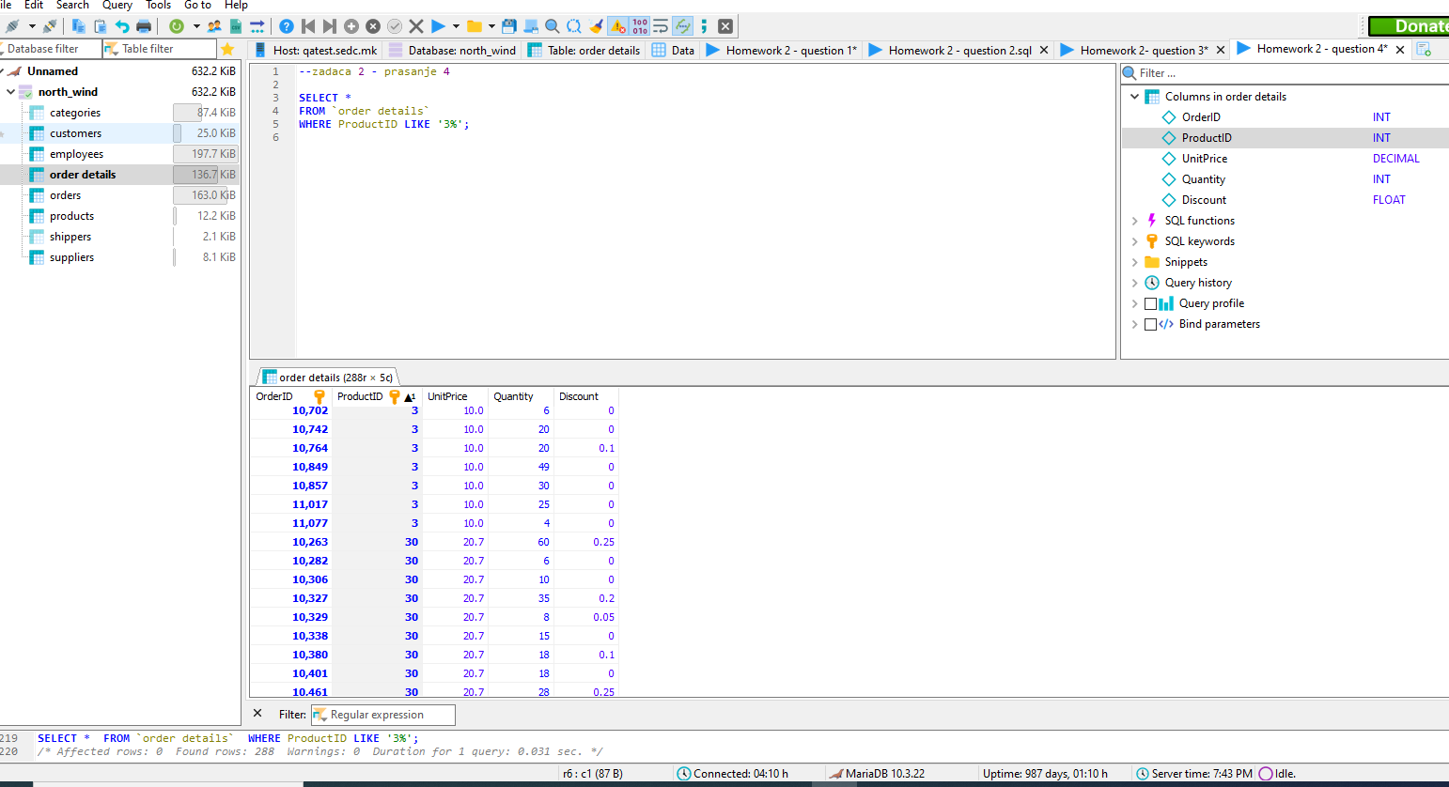

1. Write a query to select all from Order Details table where the product ID number is starting with the number 5 but exclude the single digit numbers.

**SELECT** *

**FROM** `order details`

**WHERE** ProductID **LIKE** '5_%';

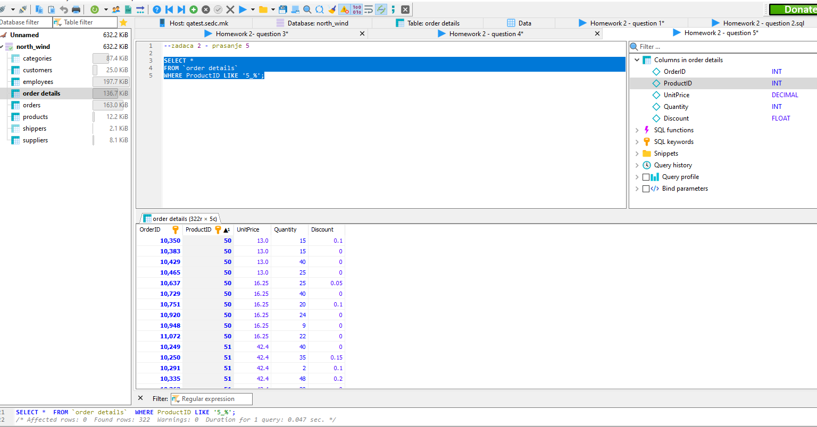

1. Write a query to select all from the Order Details table where the product ID number contains only one digit.

**SELECT** *

**FROM** `order details`

**WHERE** ProductID **LIKE** '_';

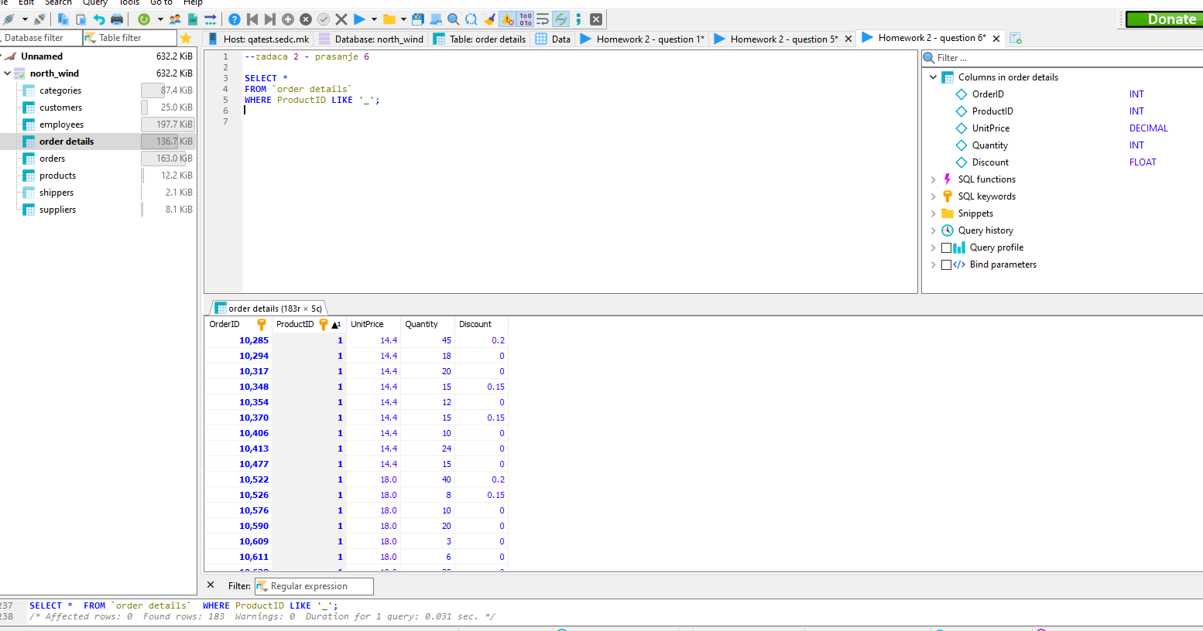

1. Now we are going to combine exercise 3 with 4. Write a query to select all from the Order Details table where the unit price is between 14 and 50 or the quantity is not between 20 and 45, but the product id number should start with the number 2.

**SELECT** *

**FROM** `order details`

**WHERE** UnitPrice **BETWEEN** 14 **AND** 50 **AND** (Quantity **NOT** **BETWEEN** 20 **AND** 45) **AND** ProductID **LIKE** '2_';

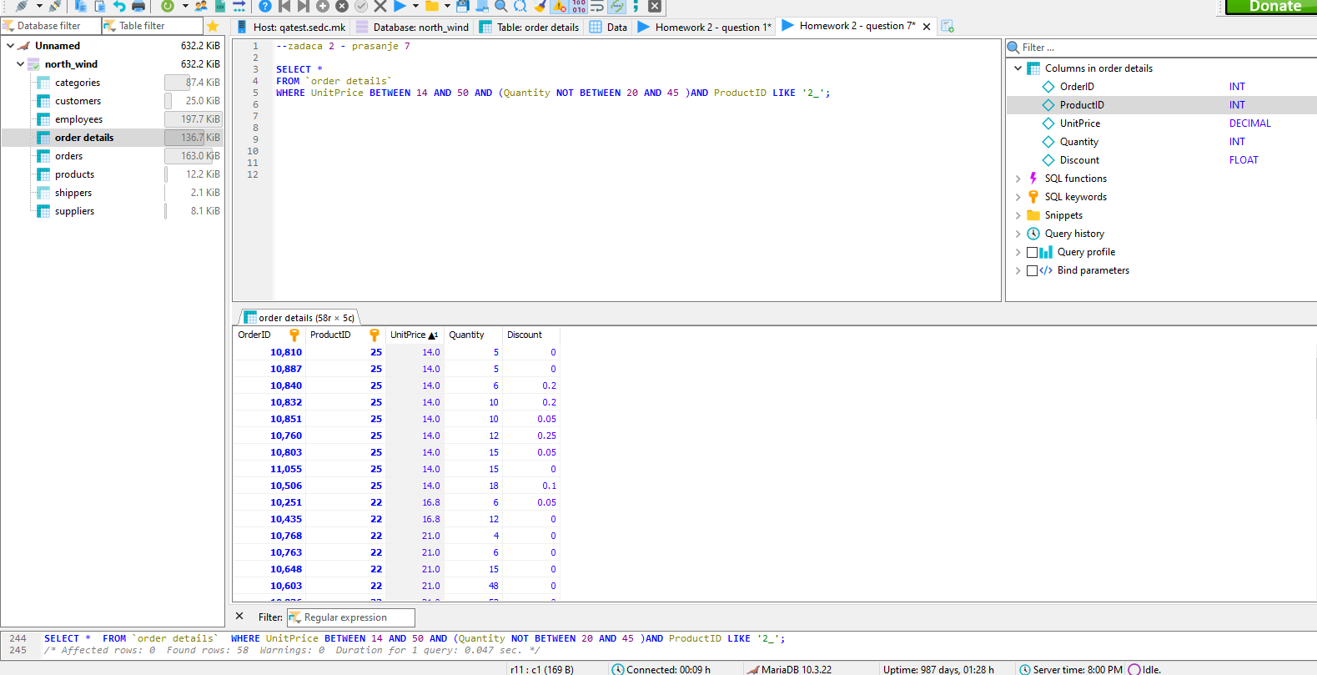

1. Write a query to select all from Customers table where the country is Germany, France and Spain.

**SELECT** *

**FROM** customers

**WHERE** Country ='Germany' **OR** Country ='France' **OR** Country ='Spain';

**SELECT** *

**FROM** customers

**WHERE** Country **IN** ('Germany','France','Spain');

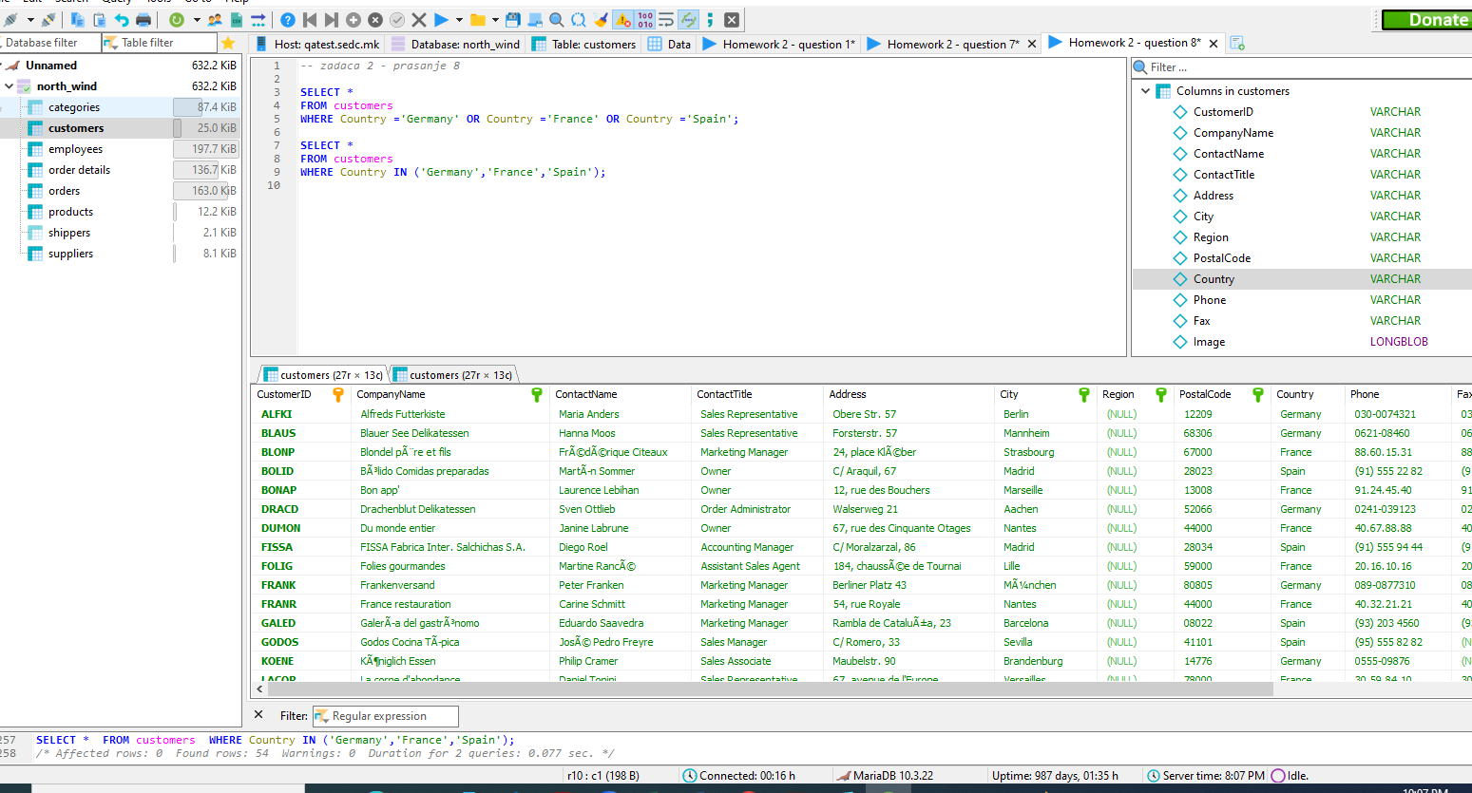

1. Write a query to select all from the Customers table where the country is Germany, France and Spain, but exclude the Cities Lyon, Paris, Madrid and Berlin.

**SELECT** *

**FROM** customers

**WHERE** City **NOT** **IN** ('Lyon','Paris','Madrid','Berlin') **and** Country **IN** ('Germany','France','Spain');

